Project 1: Workflow systems
Modeling “Ghosts of the past” quest from the Witcher game in jBPM
Aliaksandr Kladneu, master’s student. Process Mining

1. Problem Description and Solution Overview
The goal of this project is to model a quest from The Witcher 3: Wild Hunt using BPMN in the jBPM environment. The model must include actors, decisions, parallel and optional activities, and all possible ways to complete the quest. Additionally, user interaction should be represented through forms used for decision-making and data input.
To solve this problem, the quest was decomposed into a sequence of activities, decision points, and outcomes. BPMN constructs such as XOR gateways (for decisions), AND gateways (for parallel activities), and optional paths were used to represent the gameplay logic. Process variables were introduced to capture player choices and influence dialogue and outcomes. Forms were used to simulate interactions between characters and to collect input required for task execution.

2. Quest Description
The modeled quest is based on Ghosts of the Past in which Geralt investigates an abandoned farmstead and encounters Letho of Gulet. While exploring the area, Geralt must navigate traps and eventually discovers Letho hiding in a barn.
Geralt can choose to assist Letho, leading to a confrontation with bounty hunters and further investigation involving Letho’s associate, Louis. Depending on the player’s choices, Geralt may intervene in combat or resolve situations through dialogue.
In the final stage, Letho fakes his death to escape his pursuers. Geralt is then faced with a final decision: invite Letho to Kaer Morhen or allow him to leave for Zerrikania. The quest contains multiple decision points and optional activities, resulting in different narrative outcomes.

3. BPMN Model Description

3.1. Overview of the Process
The quest is modeled as a sequence of 3 embedded subprocesses:
- Farmstead
- Finding Louis
- Dealing with Bounty Hunters

The process implementation mainly relies on user tasks as the quest itself introduces a series of scenes and actions which a main character - Geralt - is supposed to live through. The following picture introduces high-level overview of the process:

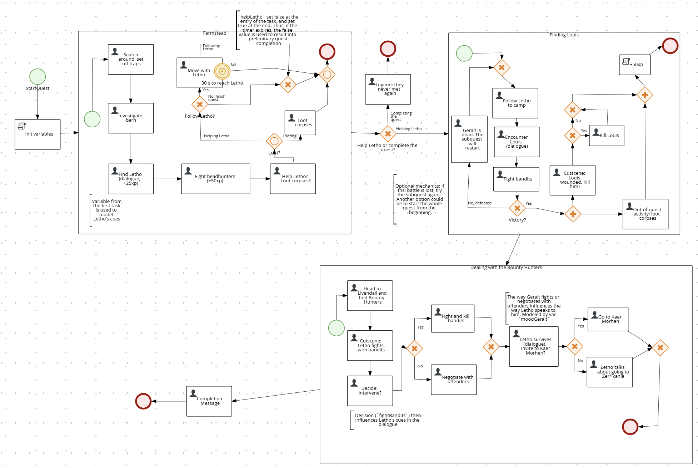

Figure 1. High-level overview of the quest.

The process ensures that all possible paths of the quest are represented.

3.2. Decision Points, Optional Activities and Parallel activities (XOR, OR, AND Gateways)
The model includes several gateways to represent decisions and branches. The next table lists split-gates in the order they appear in the model. Join-gates are described optionally. XOR and OR gates model branching points based on Geralt’s decisions made in the user tasks.
Gate | Subprocess | Decision | Condition | Outcome
OR | Farmstead | a) Help Letho?  b) Loot corpses? | a) helpLetho==true  b) lootAfterFight==true | a) Geralt will have to follow Letho (given 30 seconds to reach Letho).  b) At the same time Geralt can loot corpses.
XOR | Farmstead | Follow Letho? | a) helpLetho==true  b) helpLetho==false | a) Geralt will follow Letho, and if they stick together (the task is completed within 30 s), the quest will continue.  b) The quest will finish.
XOR |  | Complete the quest or Help Letho to find Louis? | a) helpLetho==true  b) helpLetho==false | a) The quest completes. Legend task.  b) Finding Louis subquest.
XOR  join | Finding Louis | Merges two branches |  | a) Geralt enters the subquest for the first time.  b) The fight was lost in this subquest.
XOR | Finding Louis | Victory in the fight? | a) isBattleWon==true  b) isBattleWon==false | a) AND-split.  b) start this subquest again.
AND | Finding Louis |  |  | a) Decide whether to kill Louis  b) Loot corpses.
XOR | Finding Louis | Kill Louis? | a) killLouis==true  b) killLouis==false | a) Kill Louis.  b) -
XOR  join | Finding Louis |  |  | Dealing with Bounty Hunters subquest.
XOR | Bounty Hunters | Intervene in Letho's fight? | a) fightBandits==”yes”  b) fightBandits==”no” | a) Geralt kills the bandits.  b) Geralt negotiates with the bandits
XOR | Bounty Hunters | (Dialogue) Invite to Kaer Morhen? | a) inviteToKaerMorhen  ==true  b)inviteToKaerMorhen  ==false | a) Geralt and Letho go to the witcher’s school  b) Letho talks about Zerrikania

3.3. Forms and User Interaction
User interaction is implemented through forms associated with tasks. These forms allow:
- Decision-making (e.g., whether to intervene or invite Letho. Described above)
- Input of gameplay data (e.g., how carefully Geralt set off the traps - triggeredTraps, or to store looted items - lootedItems)
- Dialogue simulation between characters (the variables used to determine the cues said by the characters). The following vars used in dialogue simulations:
  - triggeredTraps [String] - depending on the value, Letho speaks differently to Geralt when both meet.
  - Variables used in the last subquest: moodGeralt, fightBandits, inviteToKaerMorhen - are used to model the final dialogue between Letho and Geralt.

3.4. Forms and User Interaction
Process variables used in the model include:
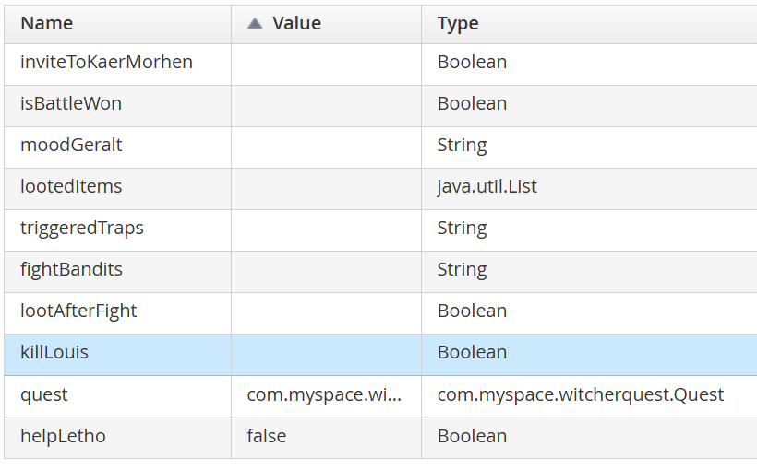
Figure 2. List of the process variables
quest variable is global for the whole process and consists of two fields: loot [List] and totalReward [int]. Additionally, user defined methods were implemented in the java-class ‘Quest’ to print debug information, and increase reward/list of looted items.
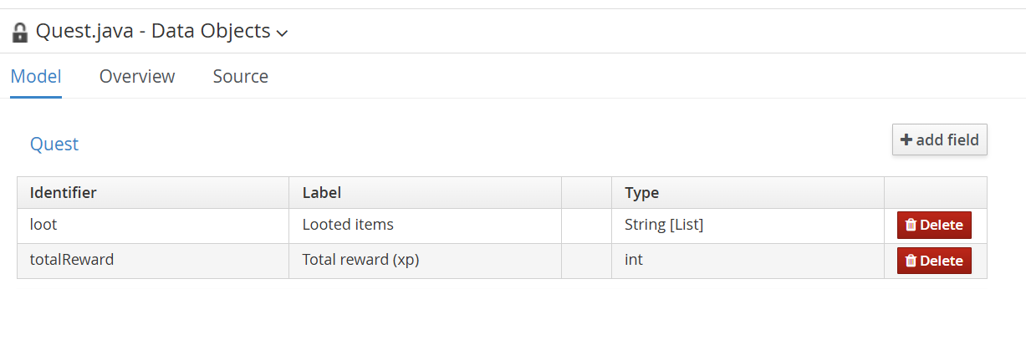
Figure 3. Quest class
Script tasks and actions at the entry/end of a user task are used to initialize some variables and modify the main - quest - variables. For example, the following task increases total reward.
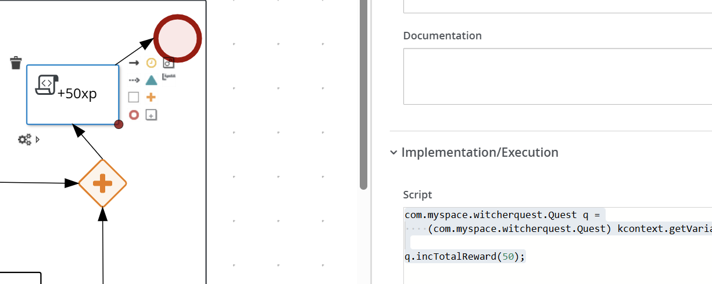
Figure 3. Script task increases total reward at the end of the subprocess

3.5. Actors
All user tasks are assigned to a single actor: Geralt. He represents the player character and is responsible for all decisions and actions within the process.

4. Modeling Decisions and Assumptions
Several design decisions were made to ensure clarity and correctness of the BPMN model:

4.1 Actor Simplification
All tasks are assigned to Geralt, as he is the only decision-making entity controlled by the player. Letho is treated as an NPC whose behavior is predefined by the quest scenario.
Other characters, such as Letho, are modeled as non-player characters (NPCs). Their behavior is represented through variables-driven dialogue (as described in 3.3) and responses rather than independent task execution.

4.2 Abstraction of Game Mechanics
Certain gameplay mechanics, such as Witcher Senses, are not modeled explicitly. Instead, their effects are simplified and captured through variables such as triggeredTraps, which represent the outcome of perception and exploration. This avoids unnecessary complexity while preserving gameplay logic.

4.3 Dialogue Modeling
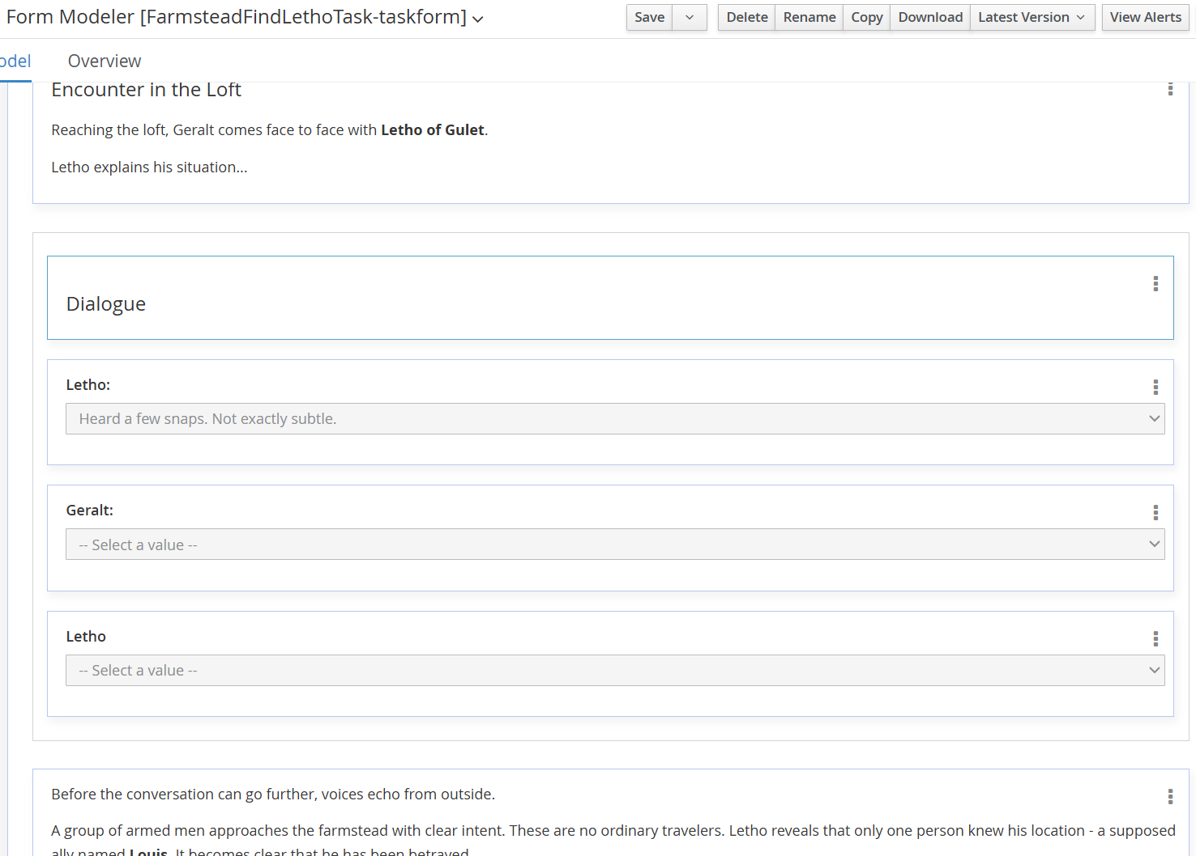
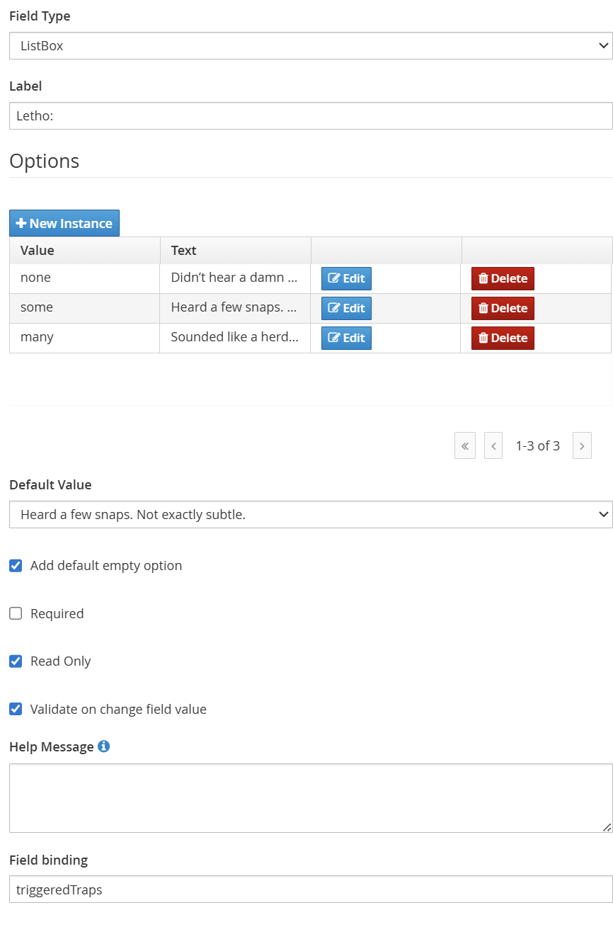
Dialogue is implemented within task forms rather than through additional BPMN branches. This allows multiple narrative variations without increasing the number of gateways, keeping the model readable and maintainable. In many cases the cues are predefined by prior Geralt’s actions (see 3.3). The following pictures represent one of such dialogues:

Figure 4. Task form of a variable-driven dialogue (Farmstead. Find Letho (dialogue))

4.4. Use of Process Variables
Process variables are used extensively to capture player choices in the forms and influence outcomes. This approach enables dynamic behavior (e.g., dialogue variations) without introducing excessive branching in the process model.

4.5. Branching
Mandatory tasks (e.g., following Letho) are enforced through control flow (additionally, a boundary event is used to enforce the completion of the task within 30 s to model actual following behaviour), while optional actions (e.g., looting) are modeled using optional paths. This distinction ensures that the process reflects actual game mechanics.

5. Example of execution
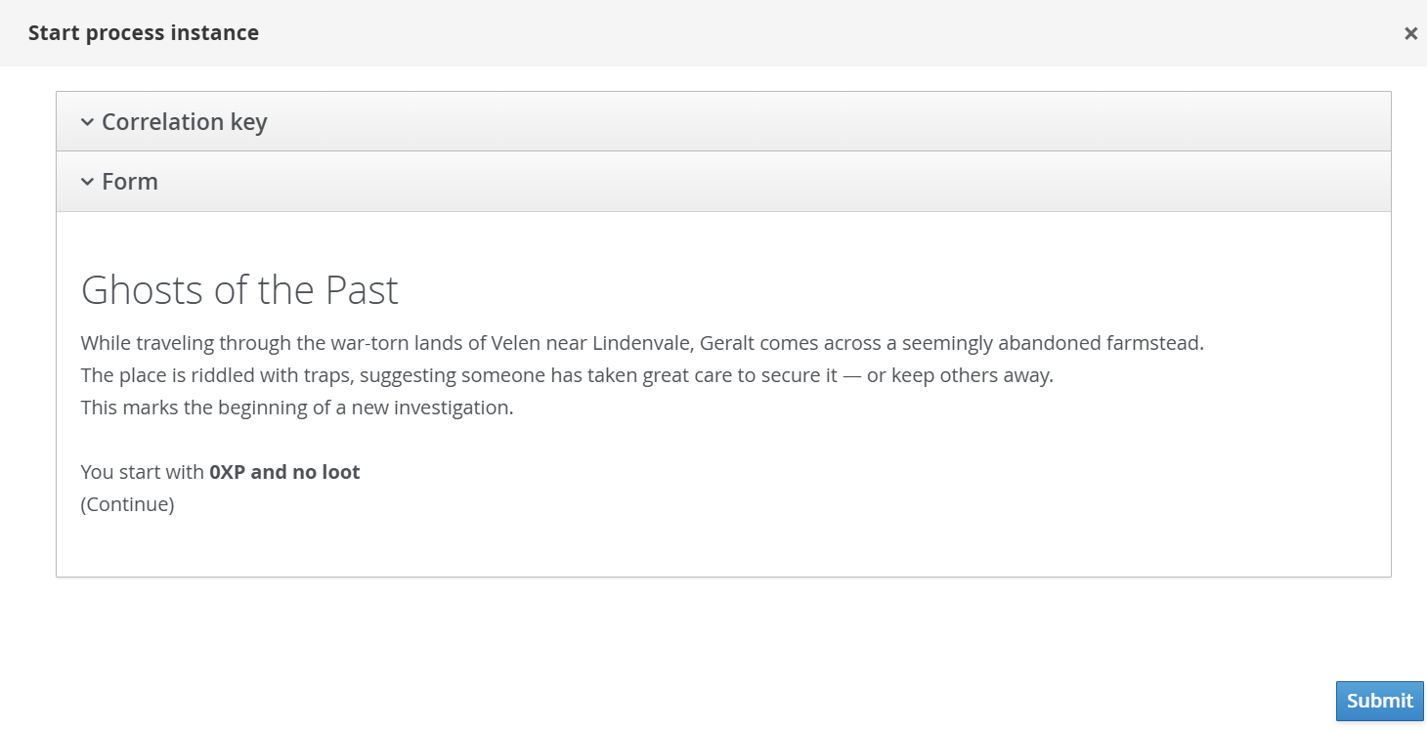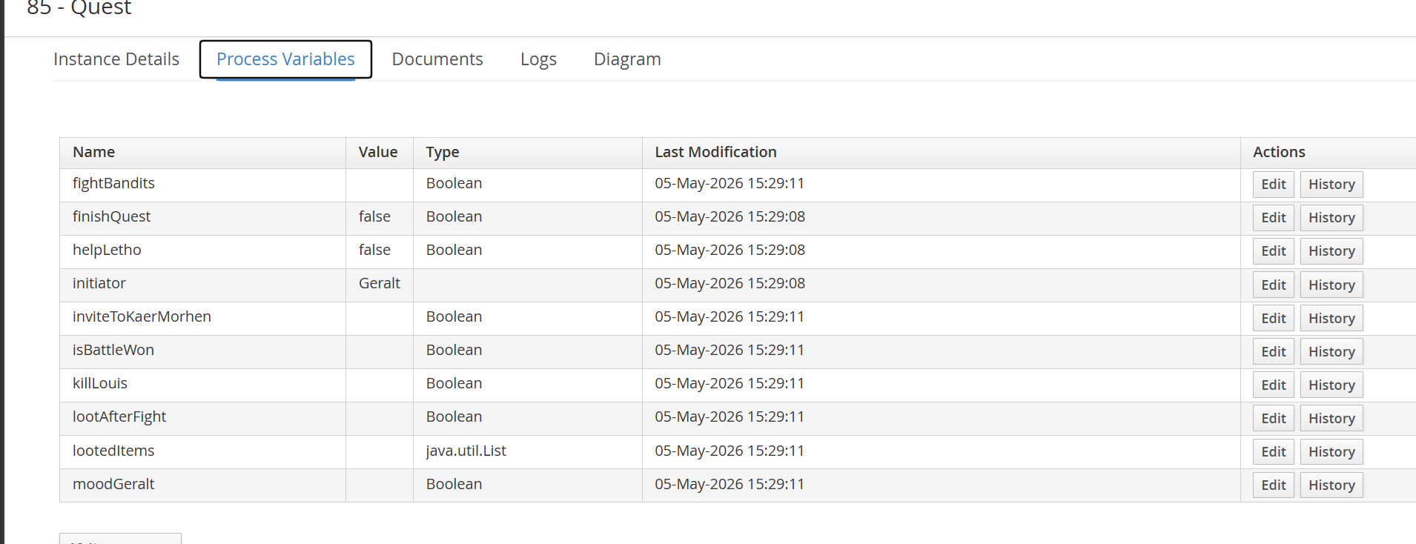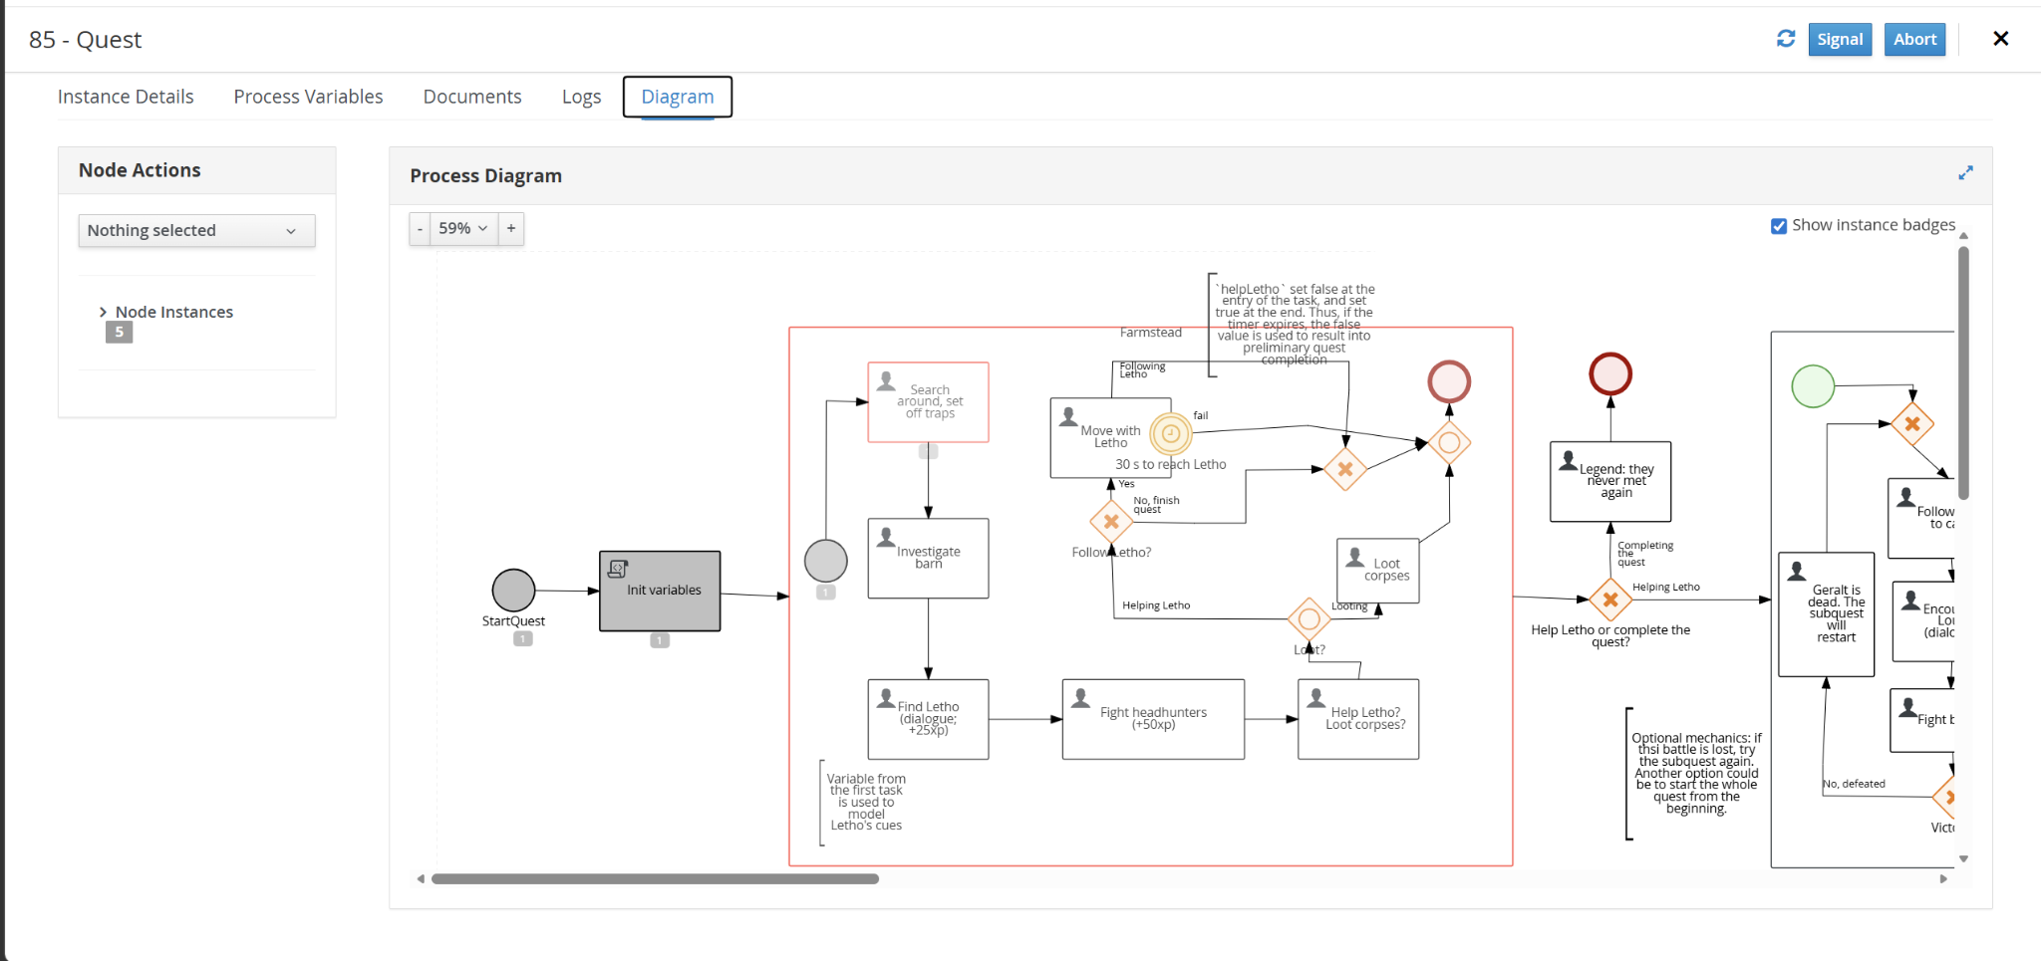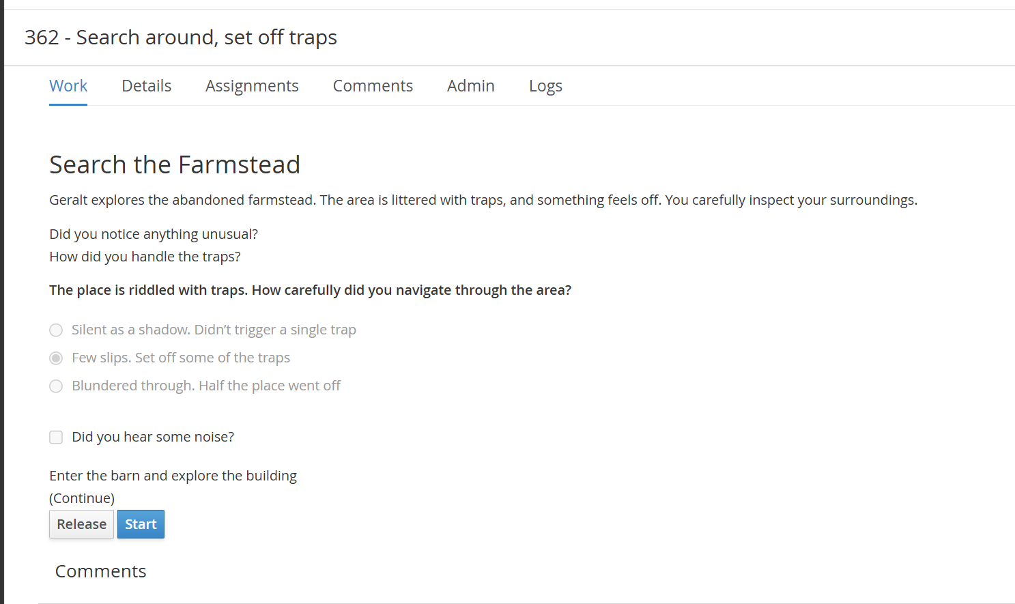
(The last action was actually chosen, so Geralt will trigger slight irritation in Letho when they meet, see the dialogue).
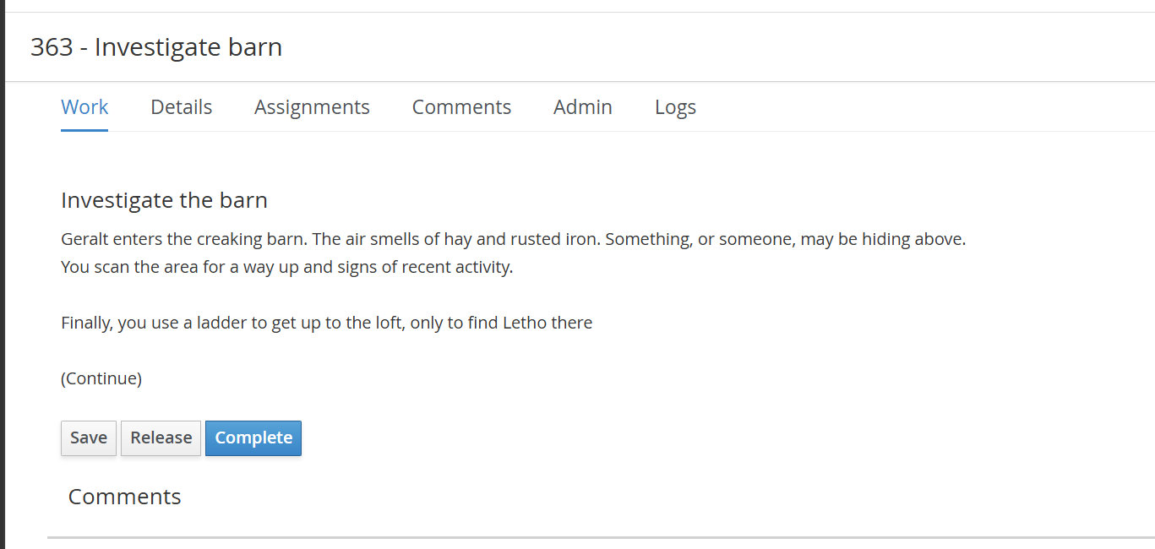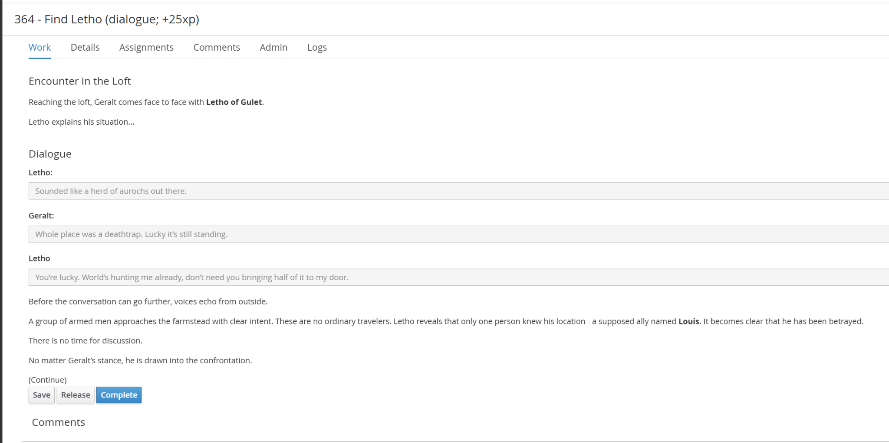
(The dialogue was predefined by the way how Geralt set off the traps in the beginning - variable triggeredTraps)

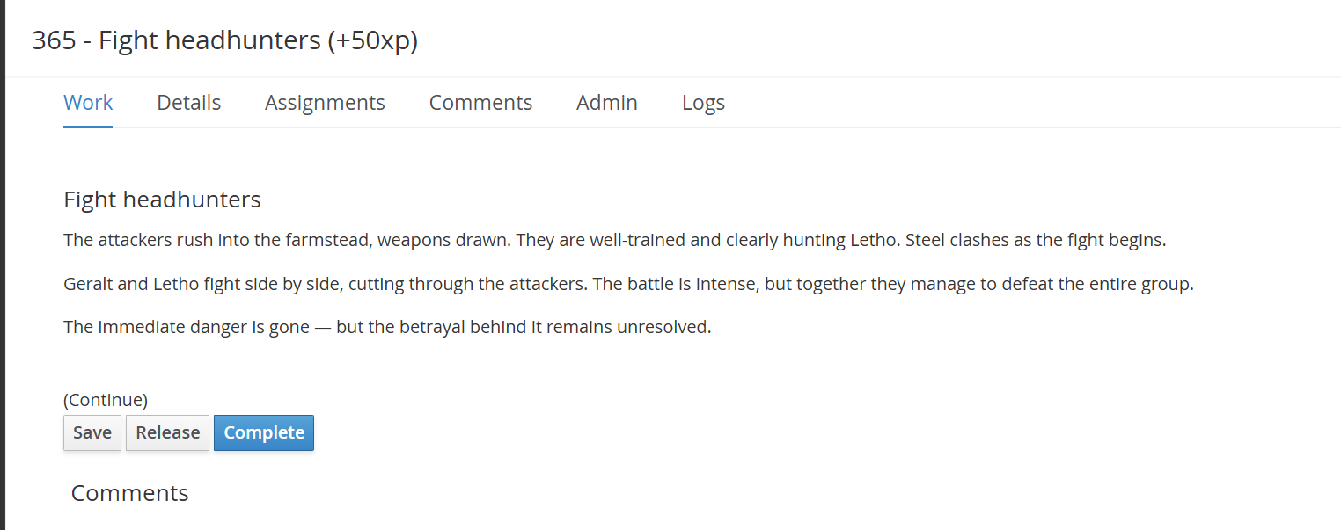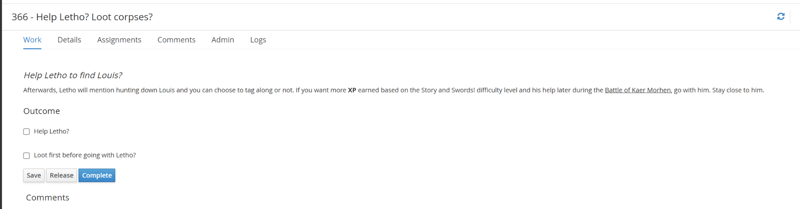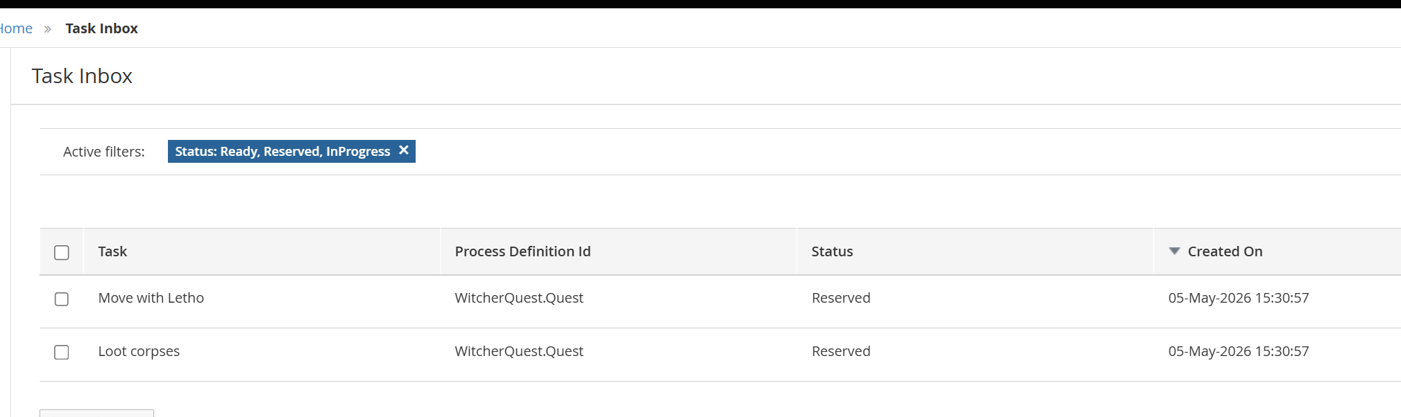

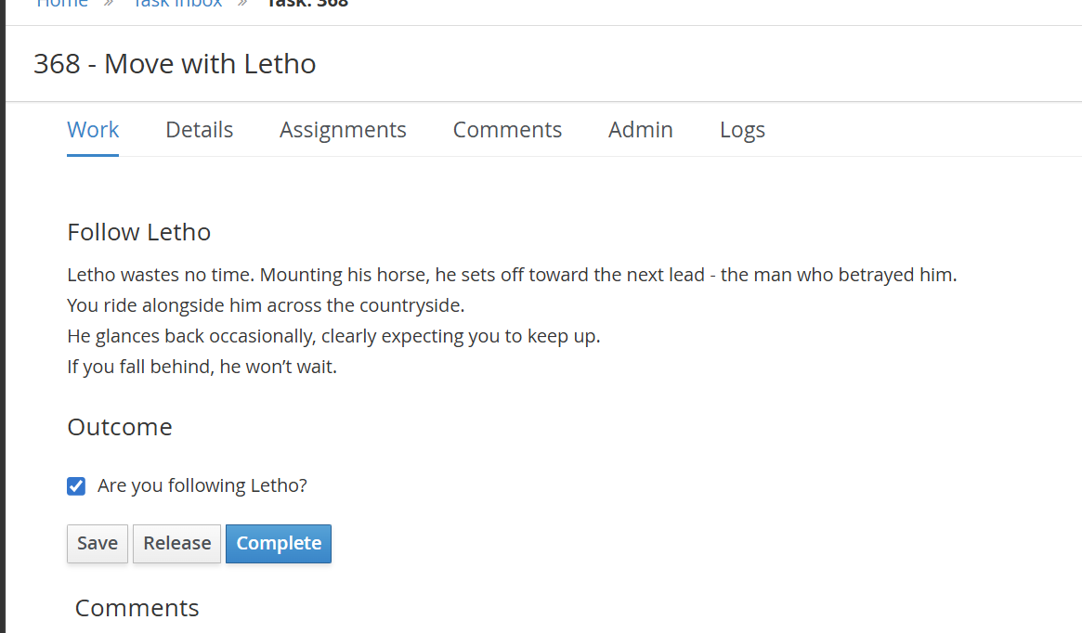Geralt should complete this task in 30 s, otherwise it will be cancelled by boundary timer event, and then variable helpLetho will remain false (set false at the entry of this task, and is to be set true once the task is completed). If this variable is false, the quest will finish once loot corpses task is done.
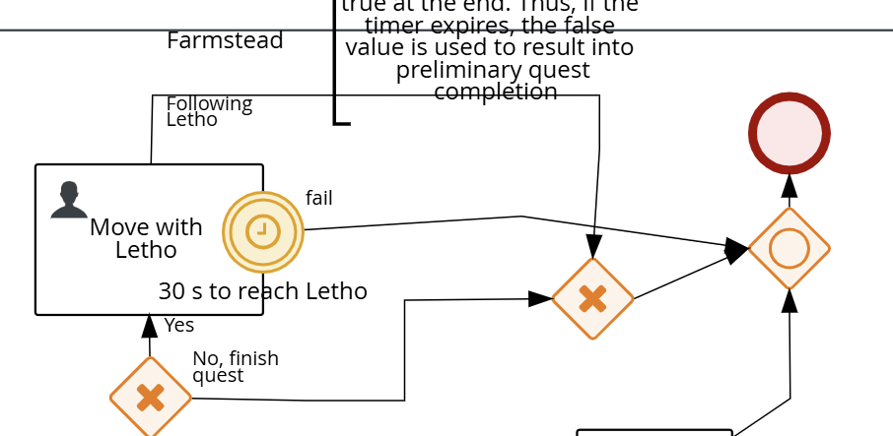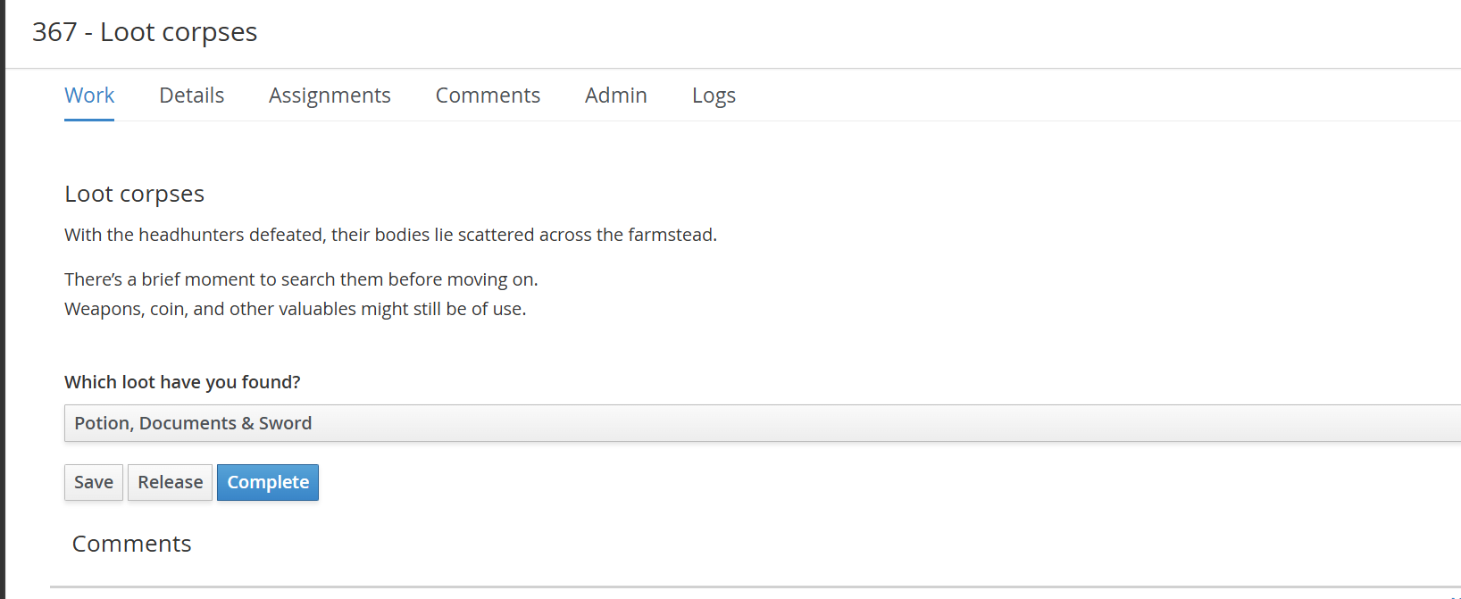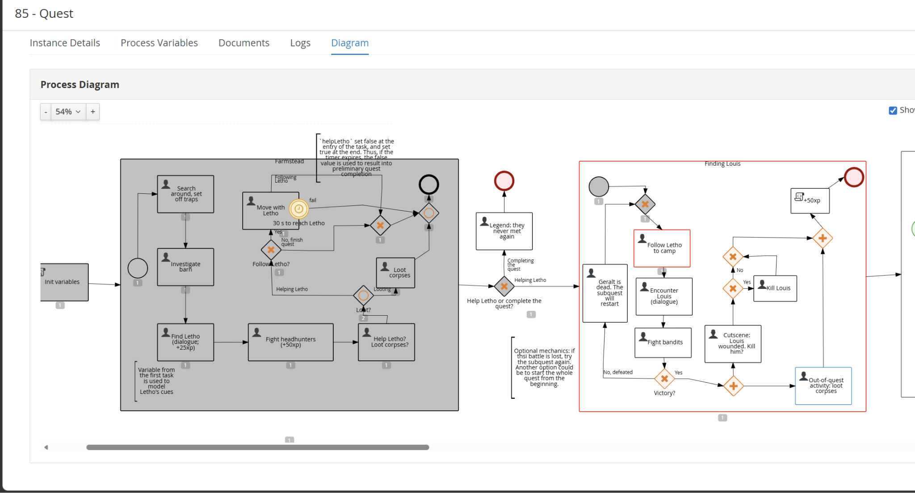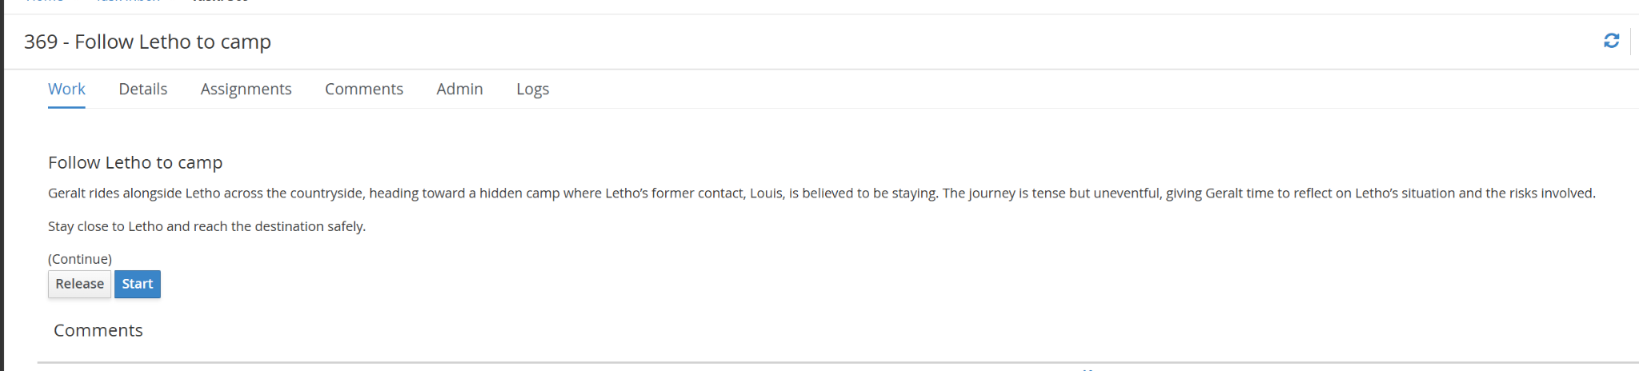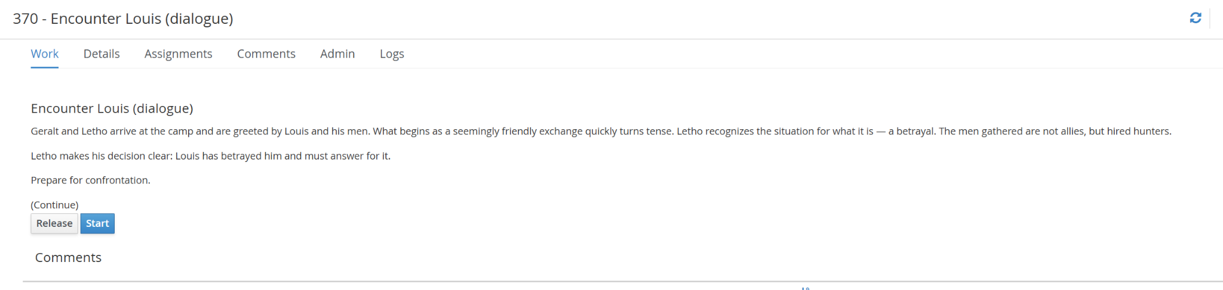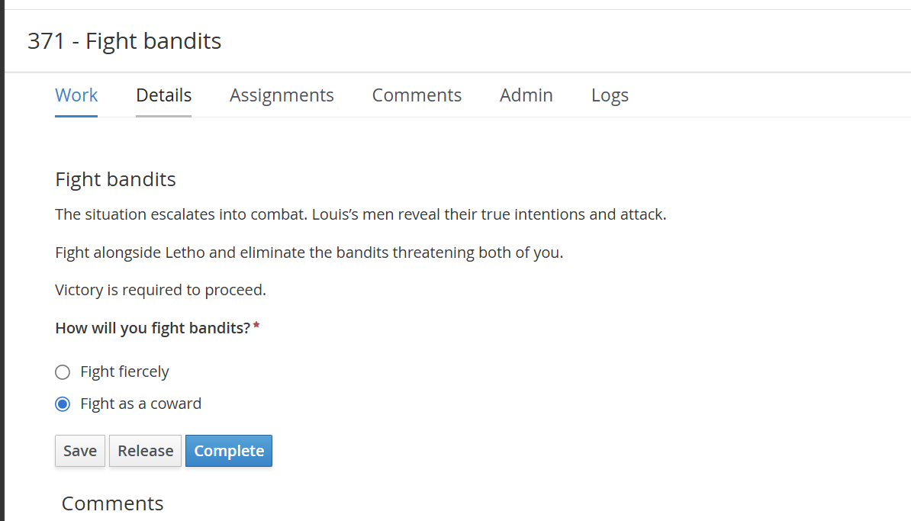

(Here Geralt makes wrong choice and Here we start again… - the 2nd part of the quest restarts)
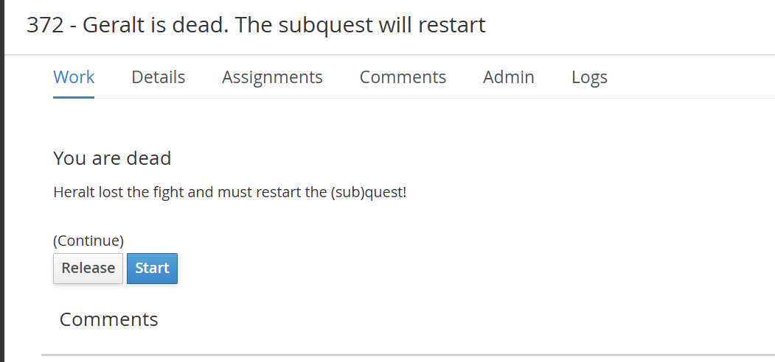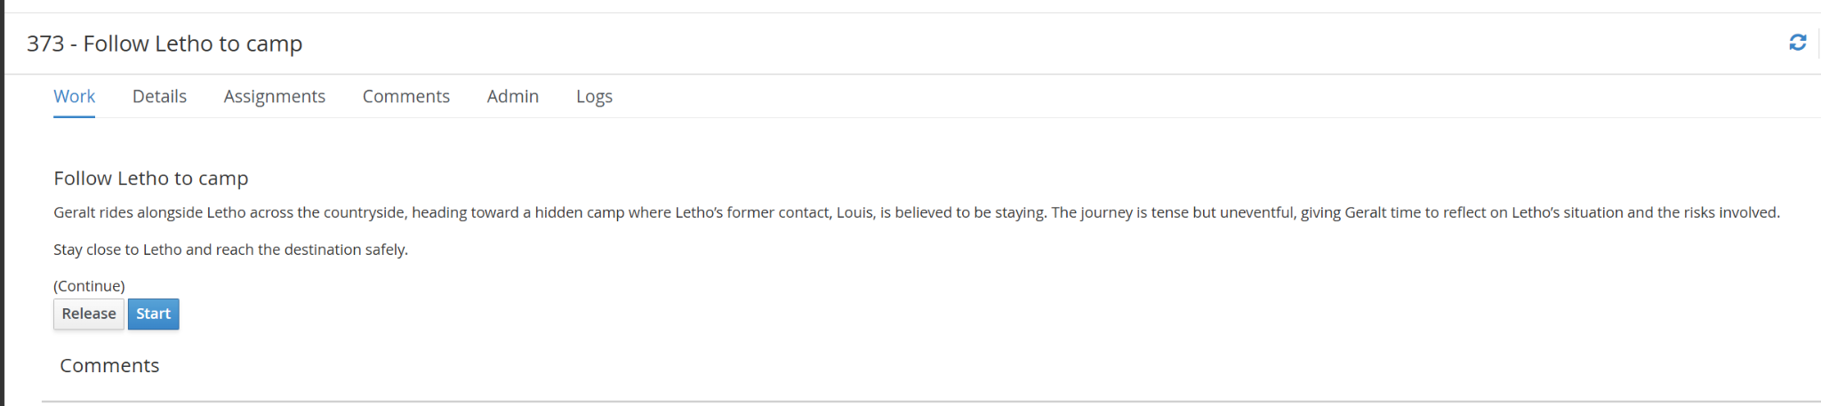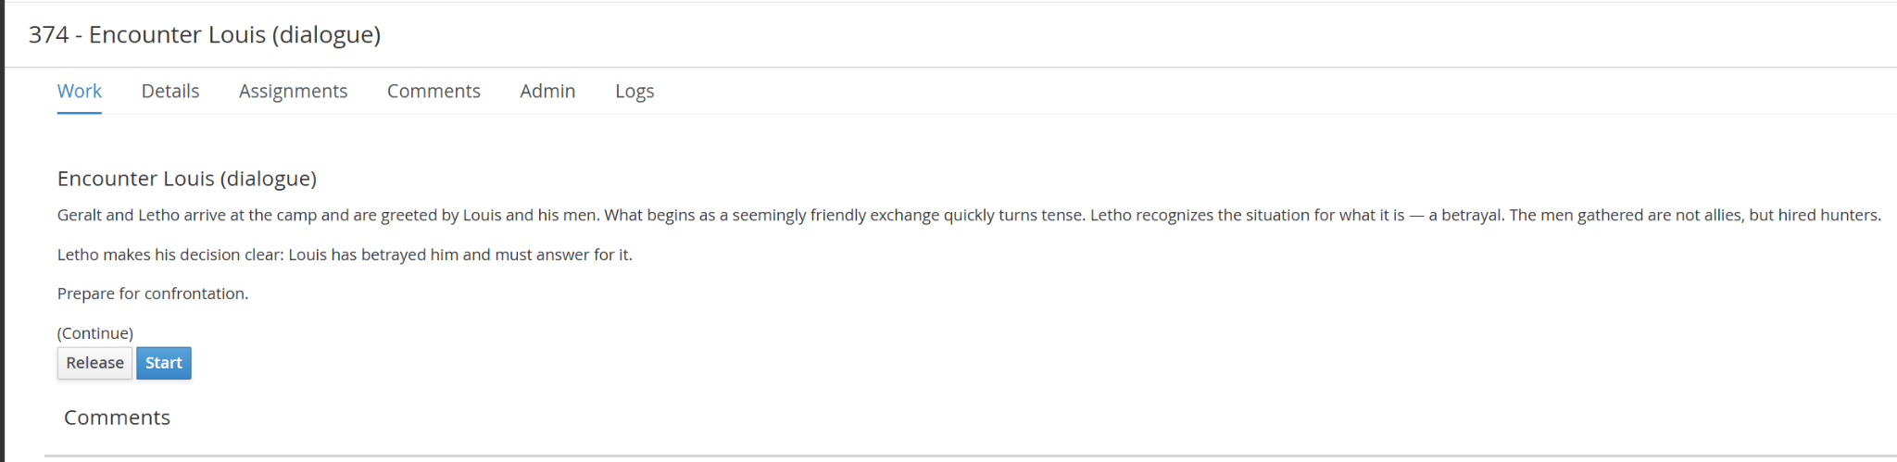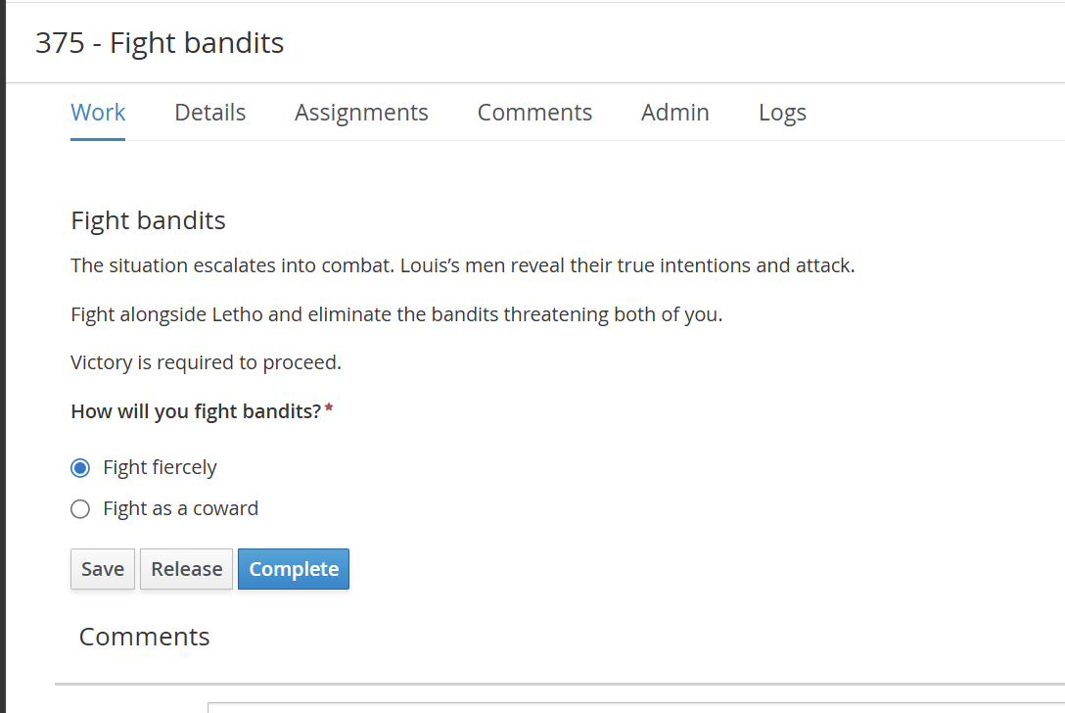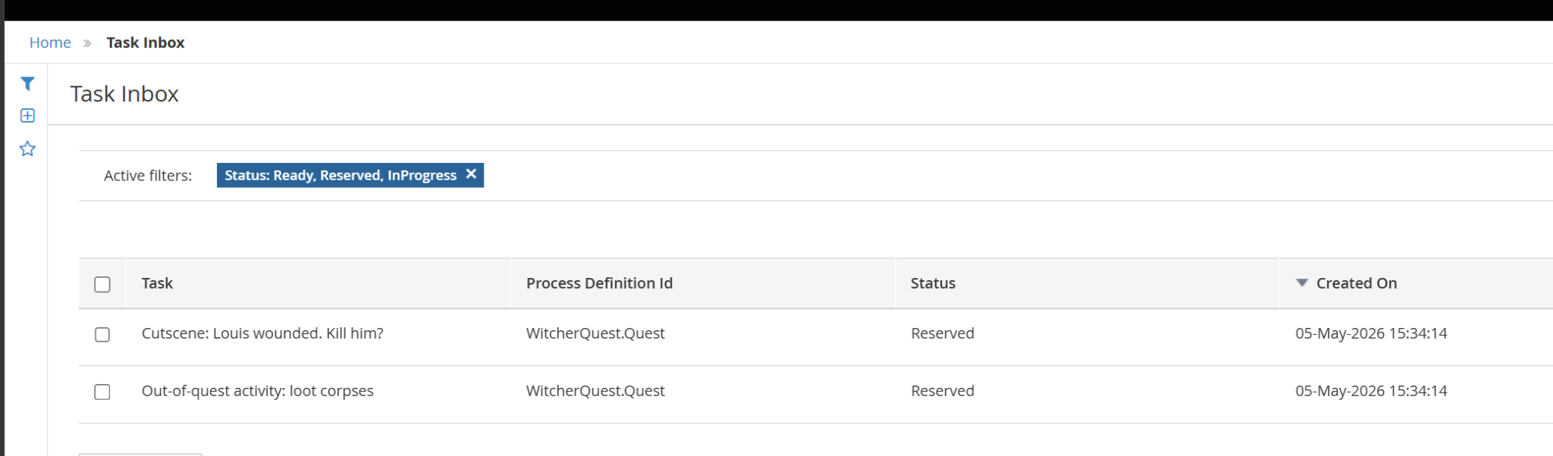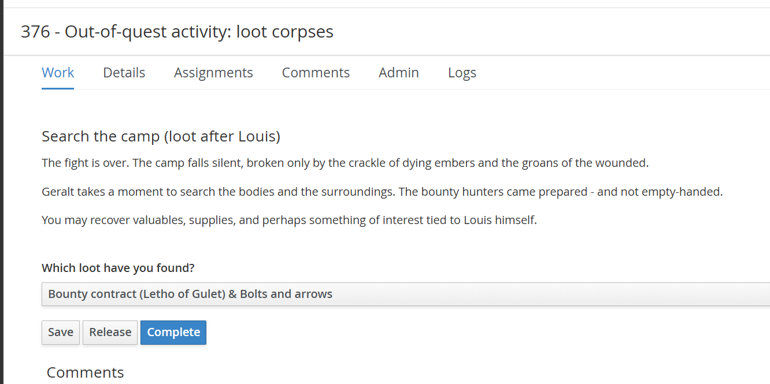These items are stored in quest.loot variable, which represent classical game mechanics.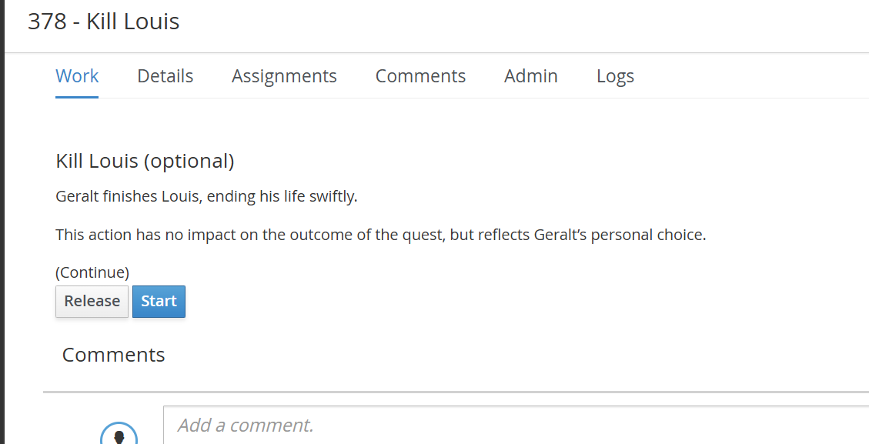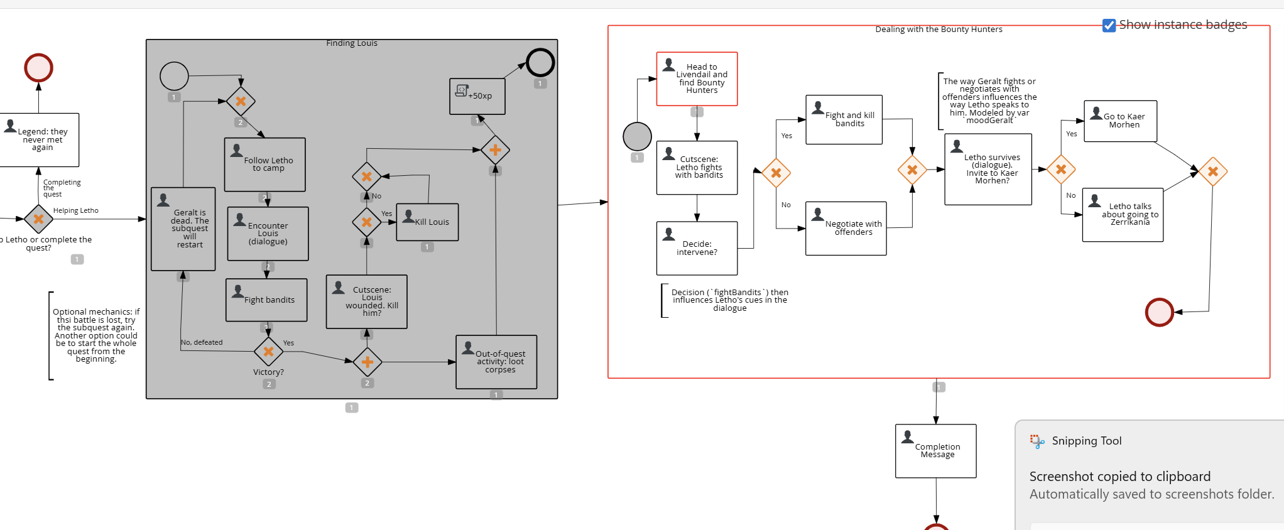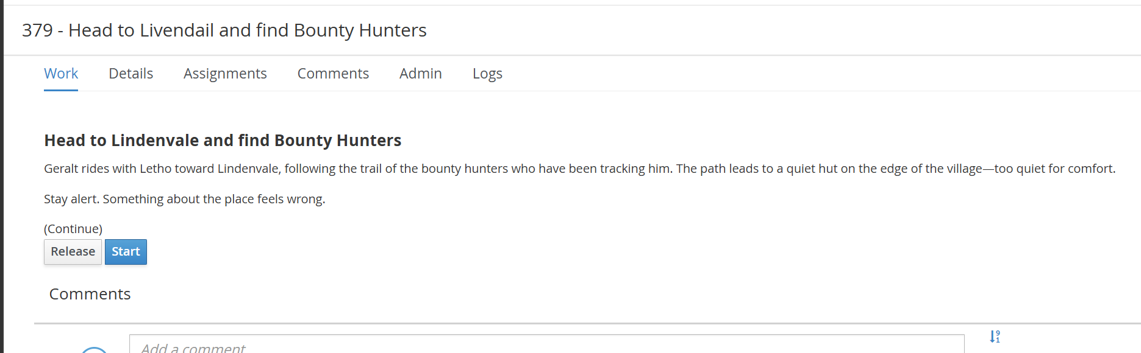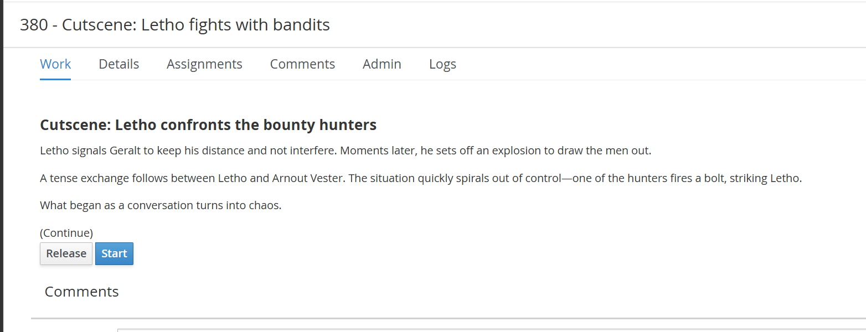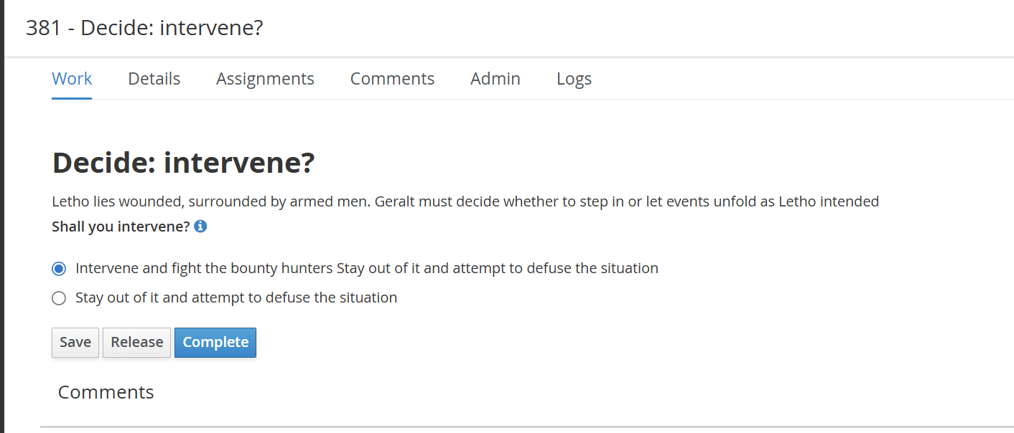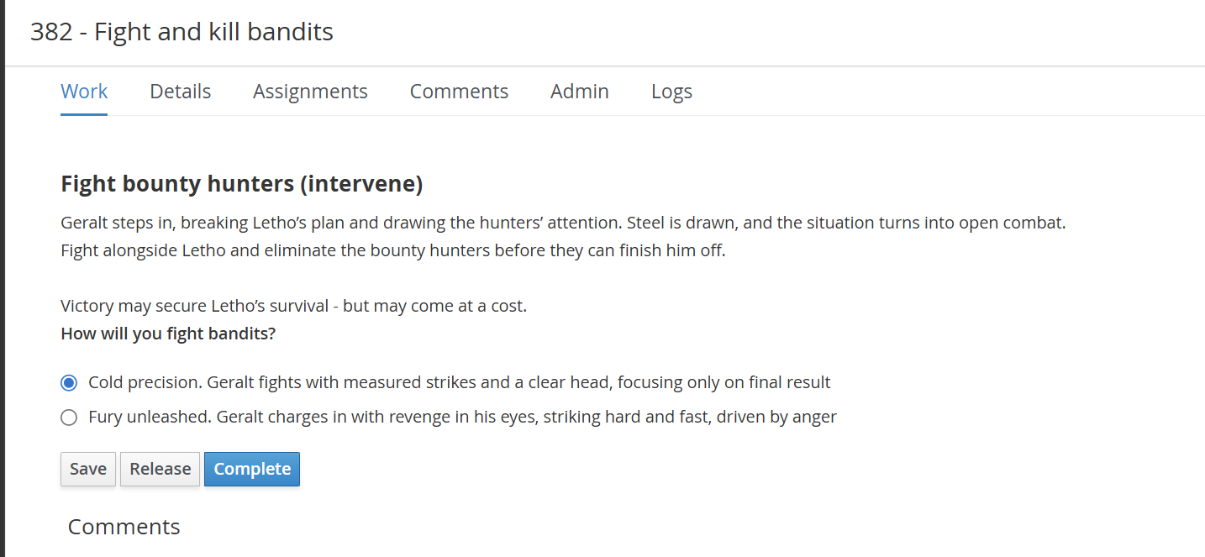How geralt fulfills these two tasks then influences the conversation between Geralt and Letho (vars fightBandits, moodGeralt)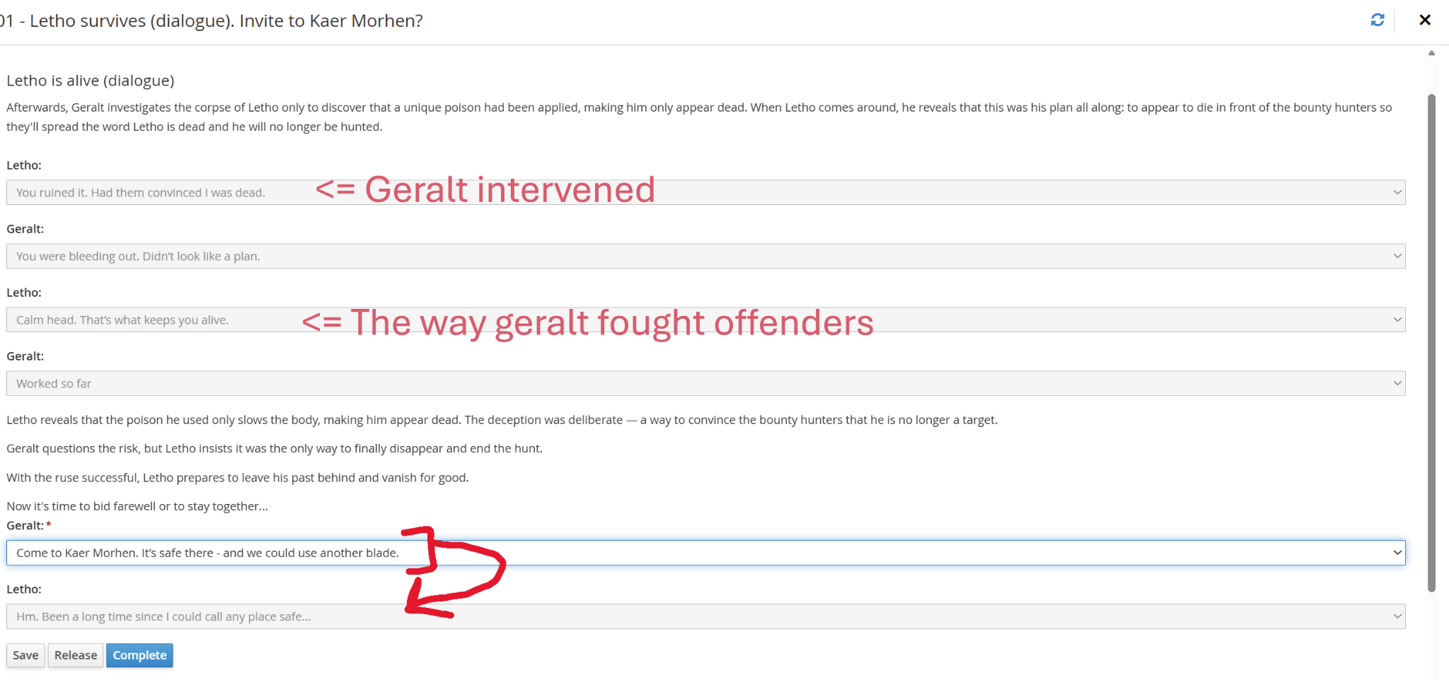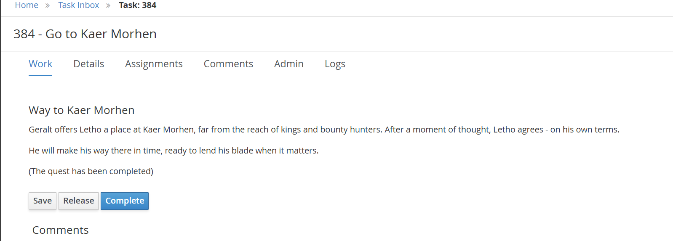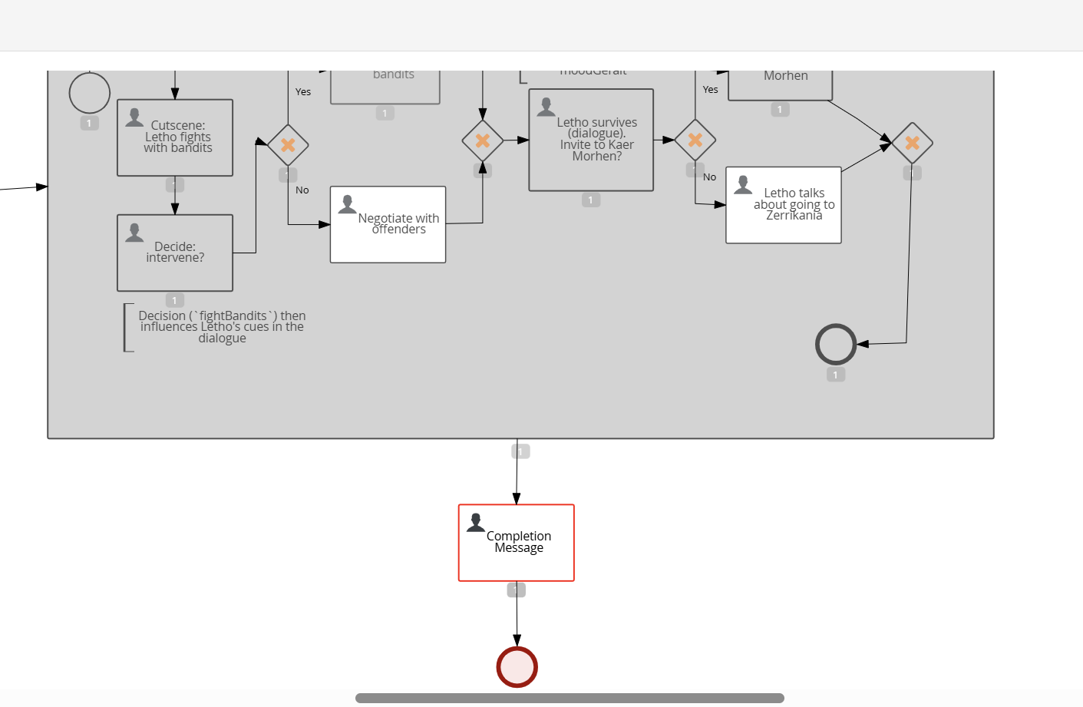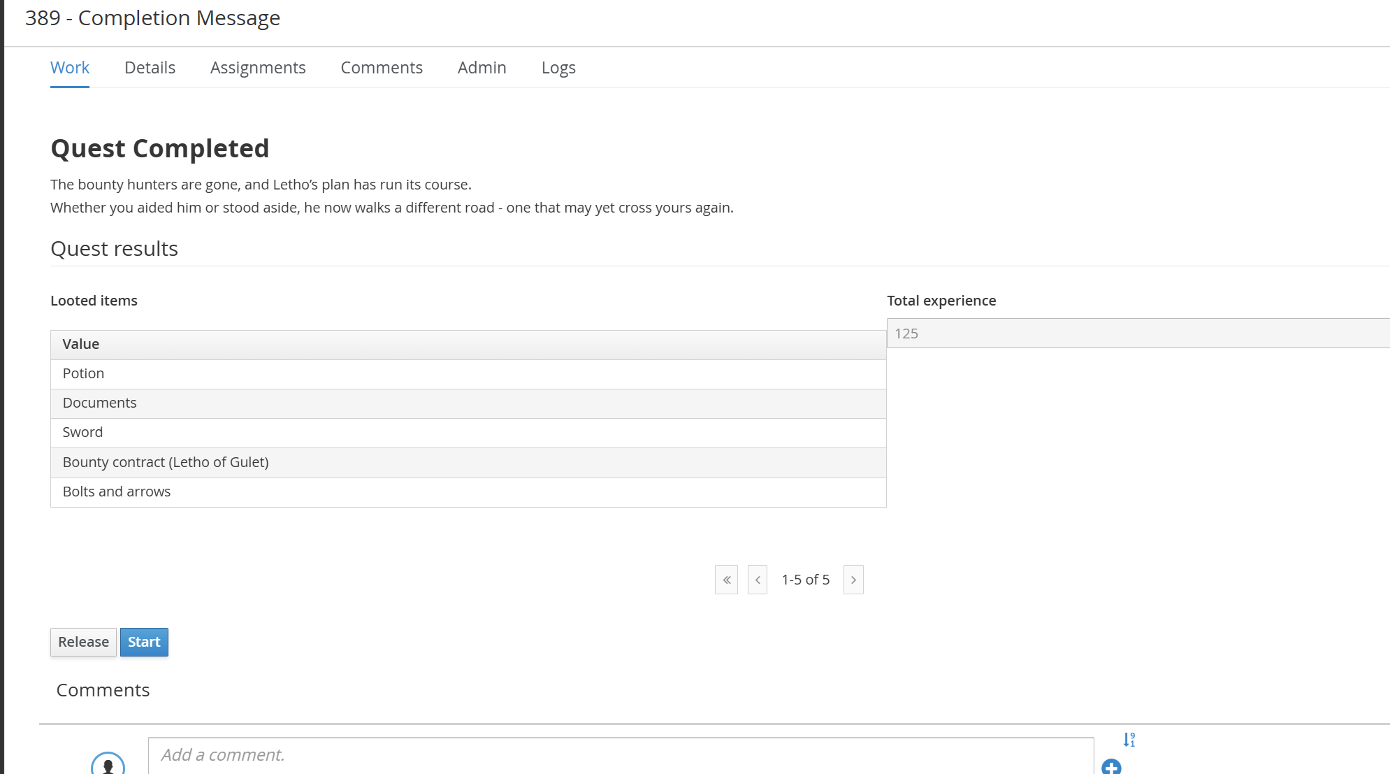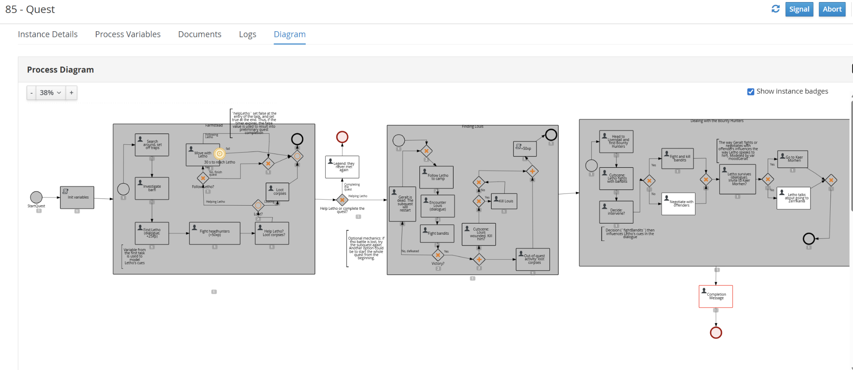
The finall flow of the chosen path.

The whole project consists of 30 assets: 